CSC 253– Computer Forensics

Spring 2019



FILE FORENSICS

NAVYA ALAPATI

PUJITHA REDDY KOPPURAPU

SHANMUKHI SAI NAINAR

Instructor Name:

Prof. XIAOYAN SUN

**ABSTRACT**

Electronic gadgets usage is increasing rapidly across the globe. Technology is taking over a major part of a human life. Every individual these days have at least one electronics with them, whether it may be Computer, Laptop, Mobile Phone, Smartwatches etc. Each electronic device works on a particular operating system and also each one has its own utilization. A device consists of multiple applications which can be downloaded by the user to make his daily routines simple. In all the appliances of our daily life, Computers/Laptops, Mobile phones, External devices play a crucial role.

As we can see that technology in these devices make our life simple, but it can even make it difficult at times. Due to the wide range of gadgets and applications availability, there is increase in digital crime rate and therefore it is a threat to safety of our sensitive information in these appliances. As the technology grows, the digital crime also increases if we don’t find a solution to it.

This situation has led to investigation of Digital forensics or in other words ‘Computer Forensics’. There are many types of forensics methods that can be performed in the part of investigation depending upon the device we want to analyze. In this project, we will look into ‘FILE FORENSICS’ on some of the devices and use different tools and techniques to investigate the crime from the evidence obtained from the crime scene.

**CONTENTS**

Introduction………………………………………………………………………………………………………………………. 4

Proposal of the project……………………………………………………………………………………………………… 5

Data Retrieval from Windows System………………………………………………………………………………. 6-9

Data Retrieval from External Device…………………………………………………………………………………. 10-12

Data Retrieval from Android Phone………………………………………………………………………………….. 13-16

Observations……………………………………………………………………………………………………………………… 17-18

Conclusion…………………………………………………………………………………………………………………………. 19

References…………………………………………………………………………………………………………………………. 20

**INTRODUCTION**

Investigating evidence is crucial for all crimes. Laptops, Mobile Phones and External Devices play a very important role in crimes these days. They are a primary means of communication in this rapidly growing technology.

In our project, we focused on File Forensic investigation of the data from the evidence obtained in the crime scene. We focus on the investigating the evidences obtained in the crime scene. Our crime scenario is as follows:

**Crime Scene:** A crime of murder has been reported in south of Sacramento city earlier on 04/05/2019. The team has inspected the location and has found 3 evidences in the crime area of victim’s house. Evidences are Windows laptop, a USB and an Android mobile phone. As per the evidences information the suspect is the victim’s neighbor.

To perform the investigation, we have used the below tools:

**Wondershare RecoverIt:** Wondershare RecoverIt is a tool to recover the data from the electronic gadgets such as Computer, Laptop, USB, SD Card, CD, Recycle Bin Recovery and many more. It can retrieve all the information that is deleted or existing in the device since it is manufactured and started to use it. Hence this can let the team analyze all the information needed to prove the suspect is guilty.

**Wondershare Dr. Fone:** Wondershare Dr. Fone is a tool to recover all the data from the mobile phone such as call data, messages, documents, applications data, videos etc. It can retrieve all the information that is deleted or existing in the device since it is manufactured and started to use it.

Evidences used in the project are:

**Windows Laptop:** We used 64-bit Dell windows laptop for the recovering of the data from the system.

**USB Drive:** We used a USB drive of size 500 MB which is connected to the windows laptop for the recovery.

**Android Mobile Phone:** We used HTC Mobile phone of model number HTC 0PCV1 which is on android operating system.

**PROPOSAL OF THE PROJECT**

**Goal:**

The aim of our project is to analyze and investigate the lost data to gather evidence from a crime scene by providing a reliable data recovery result.

**Project Solution:**

• Firstly, analysis is done to know which part of the data is lost in the system and how is it related to the crime scene.

• Once the analysis is done the access permissions are granted to find the data from the file system or the system folder.

• To start the data recover we first select the disk from which we want to recover data from the system and then select the folder, the deleted data is viewed in the tool with its created date and modified date.

• Then select RECOVER button which gives all the data that is present in the system which was deleted from that particular folder irrespective of its format.

• Recovered data is stored as a copy and the analysis is done on the duplicate folder.

**Tools and Methods:**

• Wondershare tools:

* RecoverIt
* Dr. Fone

• Deleted files Recovery:

* Windows laptop
* USB Drive and
* Android Mobile Phone.

**Roles of Group Members:**

• Navya role is to retrieve data and store the data in a secure place.

• Pujitha role is to decrypt the data and capture all the deleted files.

• Shanmukhi role is to analyze all the retrieved data and store it in a device.

**DATA RETRIEVAL FROM WINDOWS SYSTEM**

• The main objective of this project is to retrieve the data from the suspect's device and the devices that we considered for the data retrieval are:

* Dell Inspiron5567, with the operating system Microsoft Windows 10
* Pen drive
* Android mobile phone(HTC)

• In order to recover the data from the laptop, we used the tool Wondershare Recoverit. It helps us to recover the deleted data from the system. The steps described below show us how the tool is installed and what are the steps performed in order to recoup the data.

* **WONDERSHARE RECOVER IT**
* The image underneath shows us the website from where we downloaded the tool.

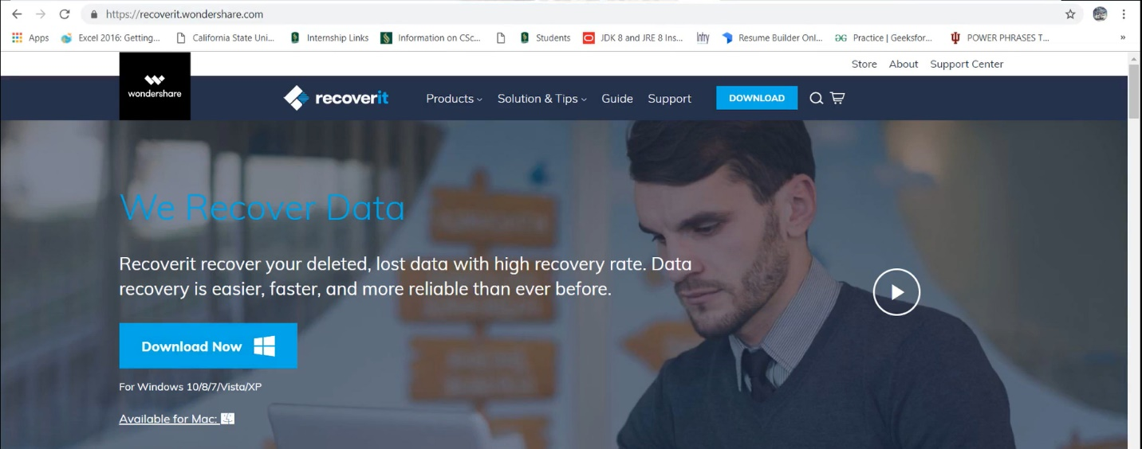

• After installation, when we run the tool as administrator, we get to see the options present in the image.

• All of these options help us to fetch the data that has been off-track in various methods.

• Deleted files recovery: The files that are deleted can be repossessed.

• External devices recovery: Data can be retrieved from the external devices, in this case we used pen drive.

• Virus attack data recovery: For suppose there was a virus attack on the system and all the data is lost, we can find the lost data.

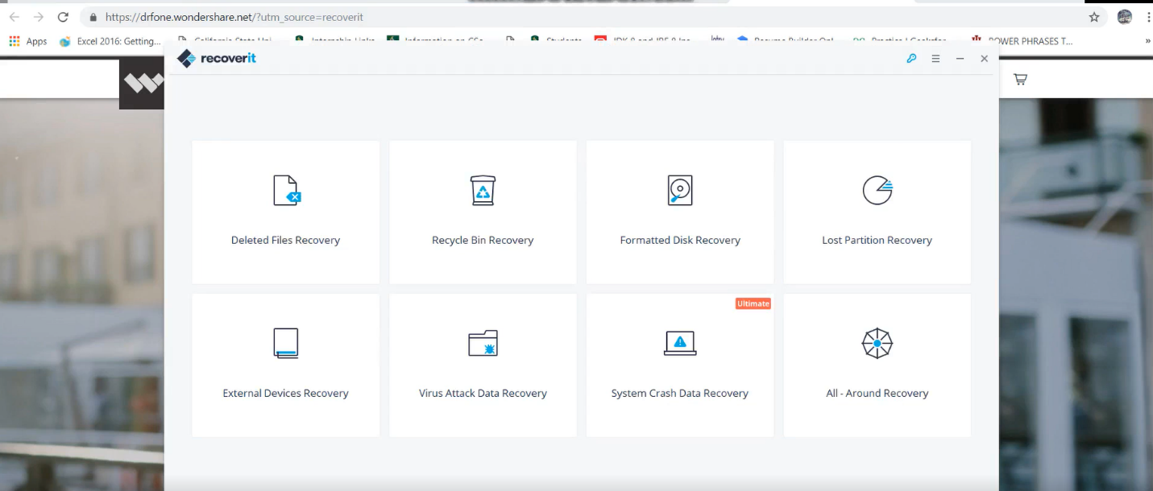

• We started recovering the deleted file from suspects laptop hoping to find some information that would support out the investigation. When clicked on the deleted files recovery option all the files are scanned and a list of all the deleted files appears as displayed below.

• We selected the files, that we thought would help us further in the investigation. All the files can also be selected but it’s a time-consuming process. So, we selected the required files to recover the data.

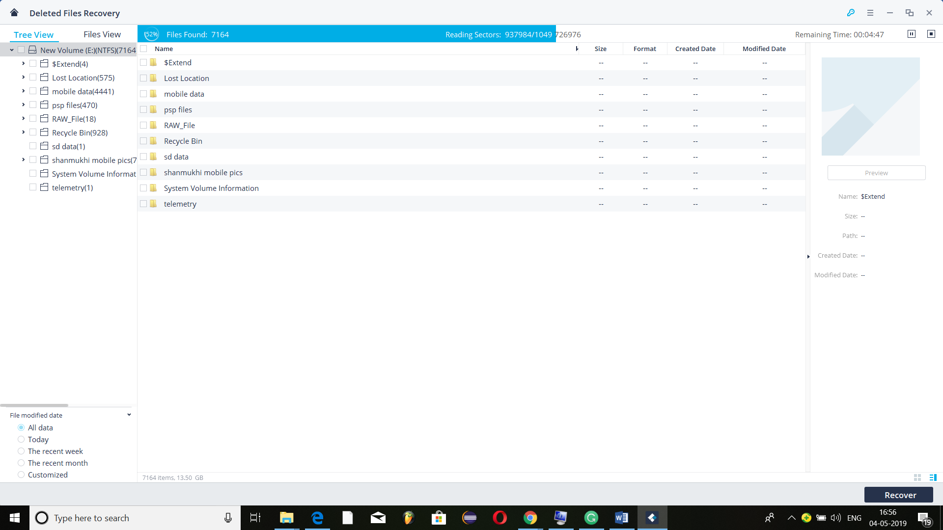

* Now when we actually opened the file in the system the folder is empty. We could see the content only using the tool.

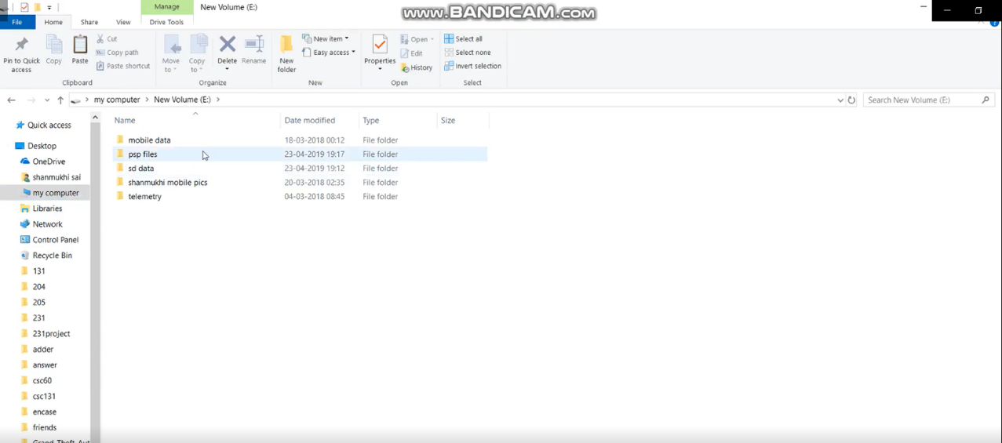

• Hence, in order to view the files, we clicked on the recover button. Then there appears a dialog box where we have to make a selection for where the recovered files have to be saved. In our case, we selected f-drive.

• There appears a clear instruction that the files should not be restored from the place where they are deleted this leads to error. In our case, the data was actually present in the e-drive hence we saved it into f-drive.

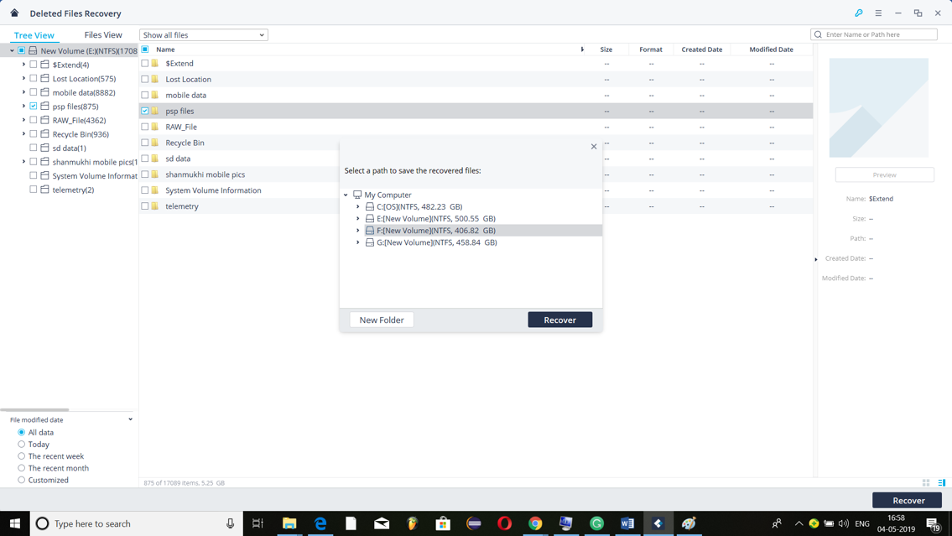

• The screenshot below shows the files that are recovered. Here we found some evidence required for the case investigation. Details such as the schedule of the one to be kidnapped and the drugs used by the suspect.

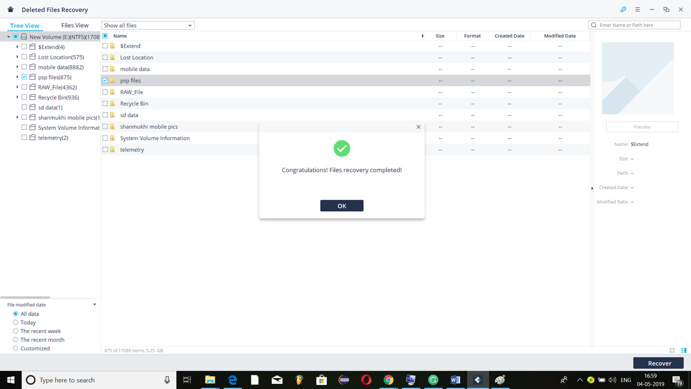

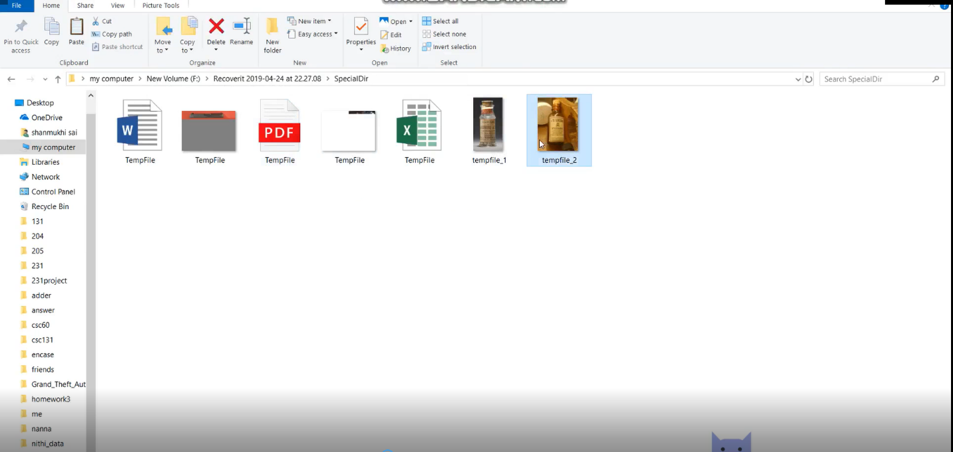

**DATA RETRIEVAL FROM EXTERNAL DEVICE**

* Now recovery from an external device our case it’s a pen drive. In general, it can be anything like:
* Digital camera
* Camcorder
* Memory Card
* iPod
* Sdcard etc

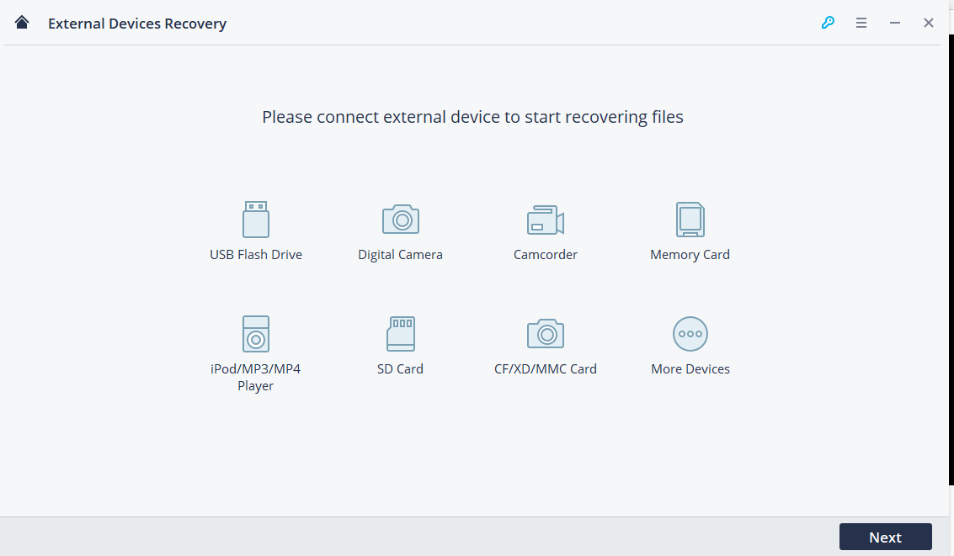

• When we plug in the drive it's detected by the tool as shown below.

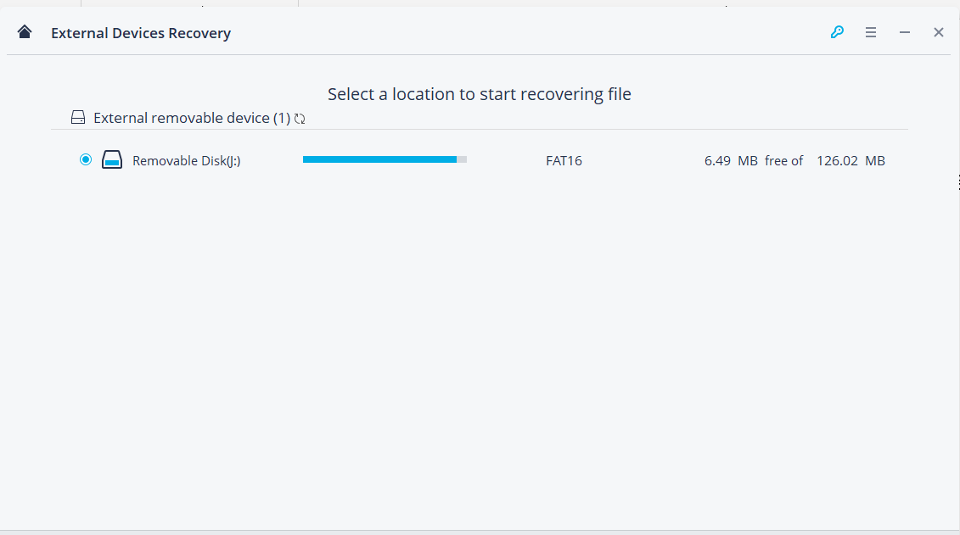

• Now when we click on the start button all the deleted files have appeared after the scan and a dialog box appears saying that scan has completed.

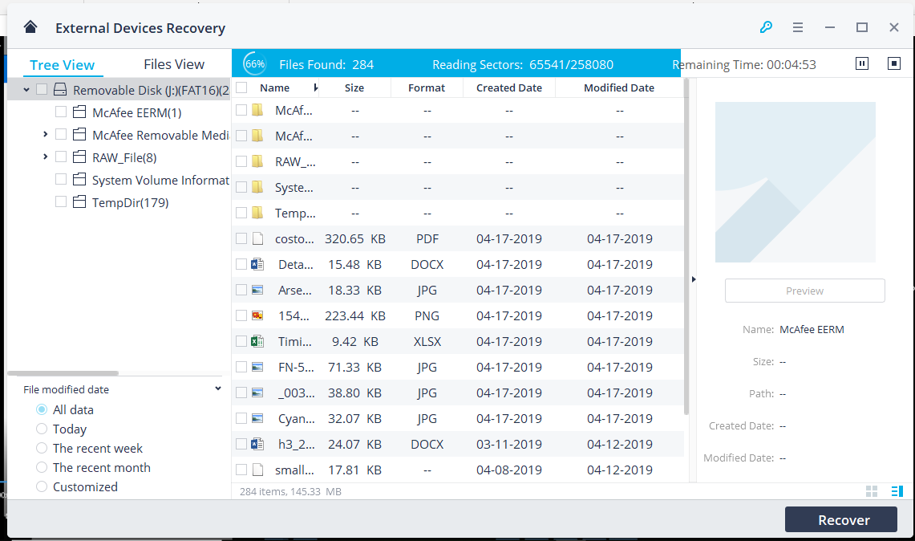

• The same way we recover the files into f-drive

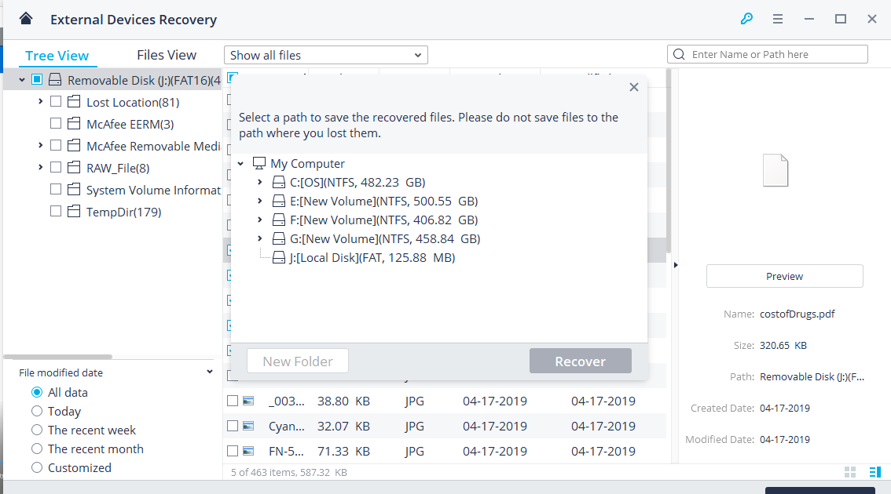

• We recovered images from the file that had details about timings of the one to be kidnapped and a detailed report of drugs that the suspect planned to use, the timings of the one to be kidnapped.

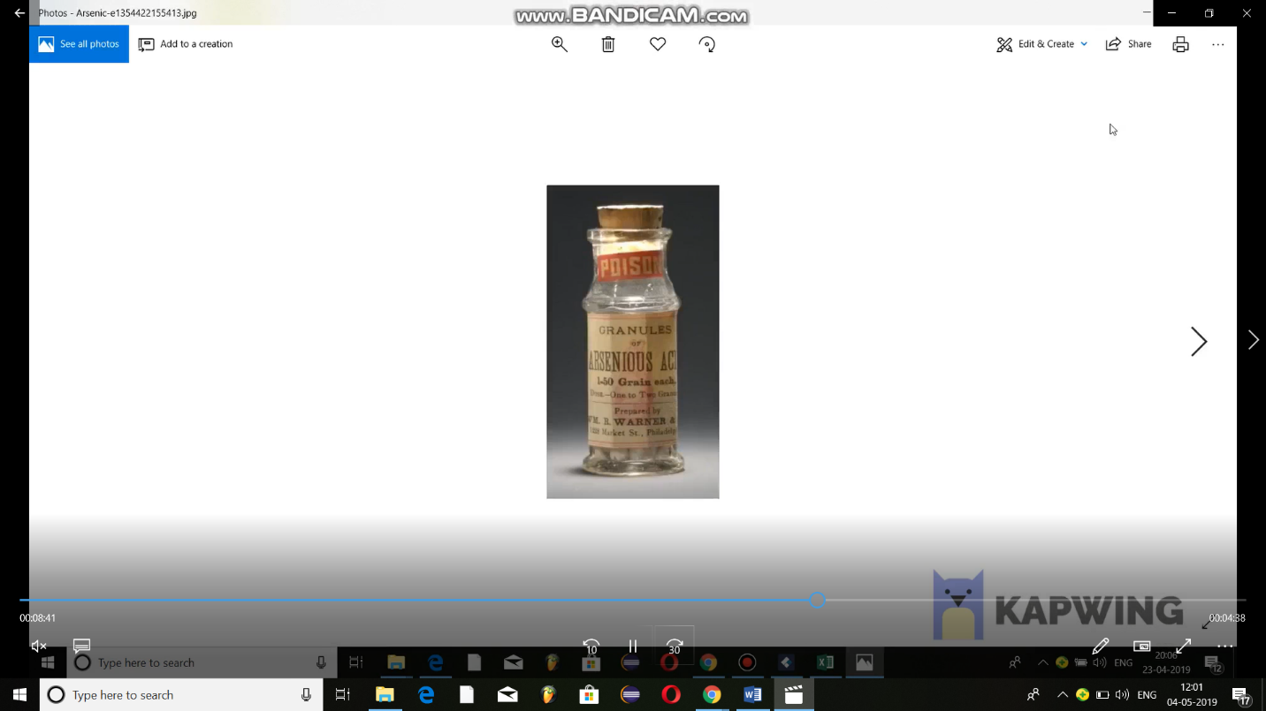

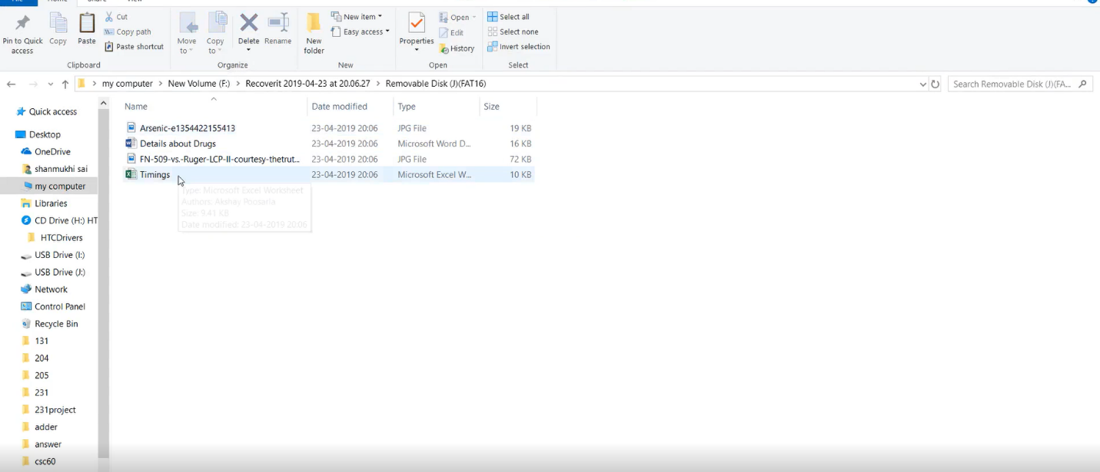

**DATA RETRIEVAL FROM ANDROID PHONE**

To Retrieve data from a mobile phone we are using WonderShare dr.fone tool. This tool Provides a complete solution for all iOS and Android devices like data recovery, data transfer, phone clone, system repair, unlock and more.

The options that can be performed are:

1. Recover data from mobile phones
2. Transfer of data between phone and system
3. Fix various IOS system issues
4. Permanently erase data from mobile phone
5. Copy data from one phone to another
6. Flexible backup and restore your phone
7. Remove your phone’s lock
8. Backup and restore your WhatsApp, Wechat, Kik, LINE.

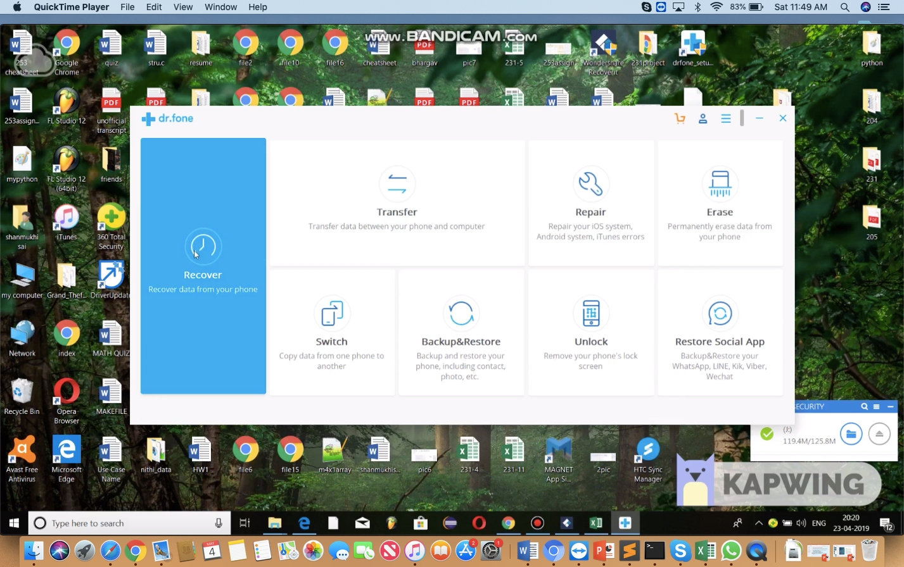

* In our project we would like to recover data from mobile phone so select first option. The connection is built between Mobile phone and the windows system.

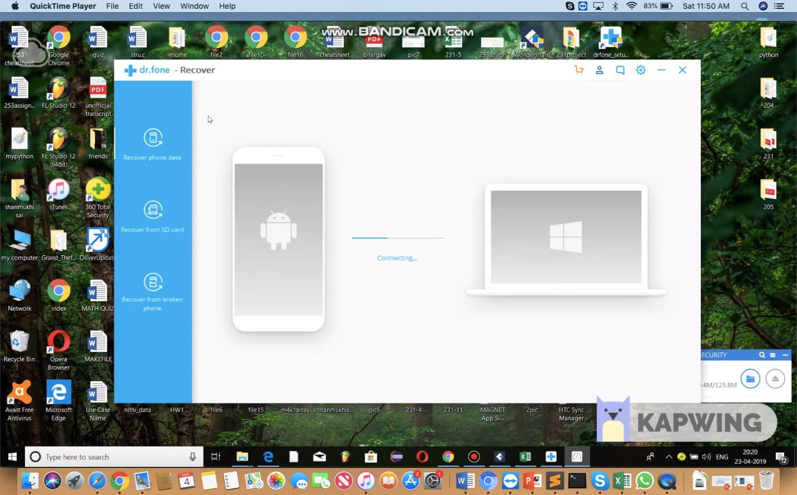

* The operations we can perform in Recover data from mobile phone are:

1. Recover phone data
2. Recover from SD card
3. Recover from Broken phone.

* We would like to recover data from the mobile phones so select Recover phone data.

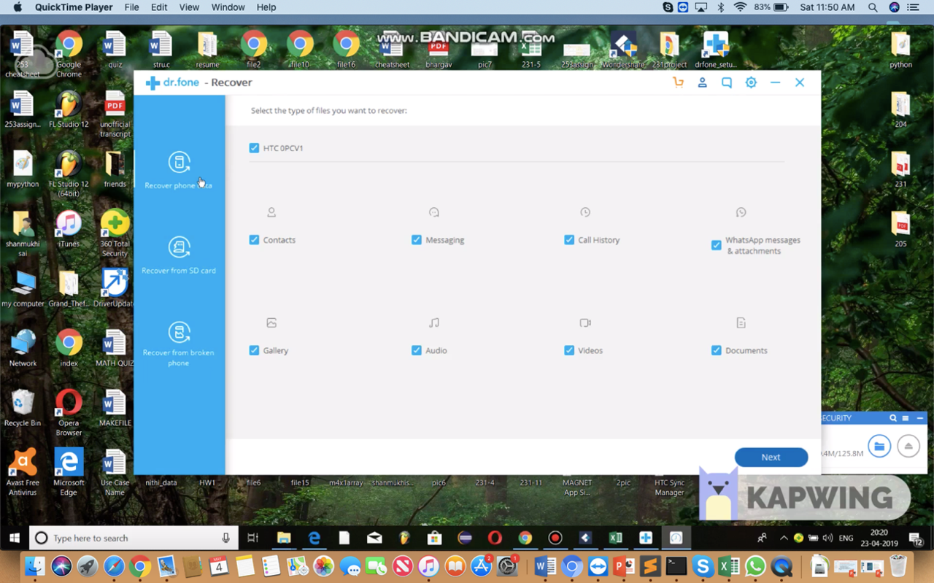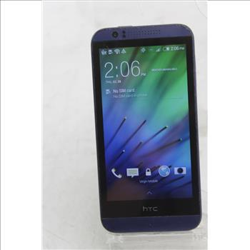

* Firstly, we select the name of mobile phone we want to recover from which is HTC 0PCV1 in this case and then selecting the type of files we want recover.
* In this case, we want to recover complete data from mobile phone, so we select everything and click on next. We need information that was deleted from the mobile phone, so we select Scan for deleted files.

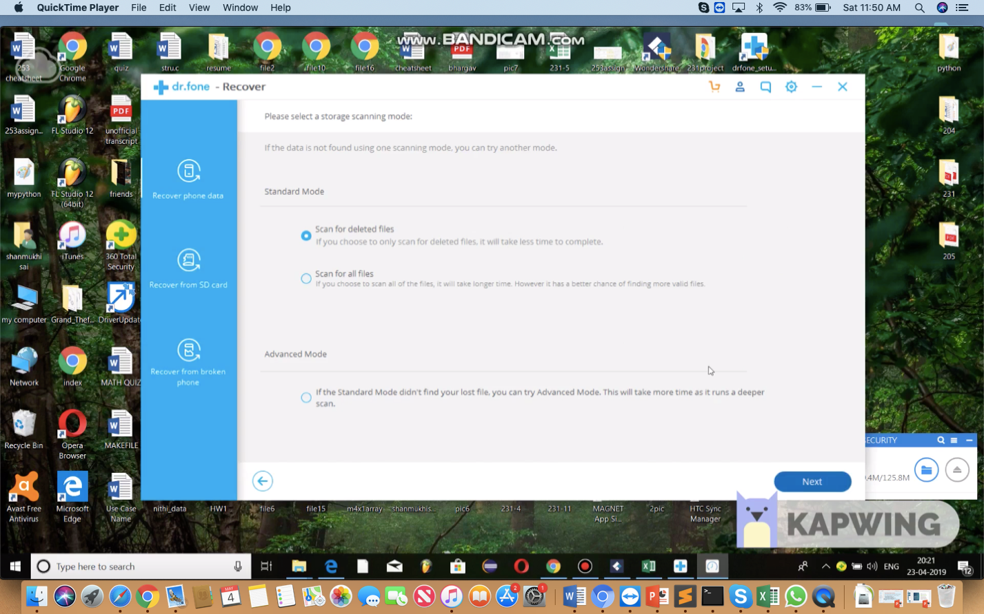

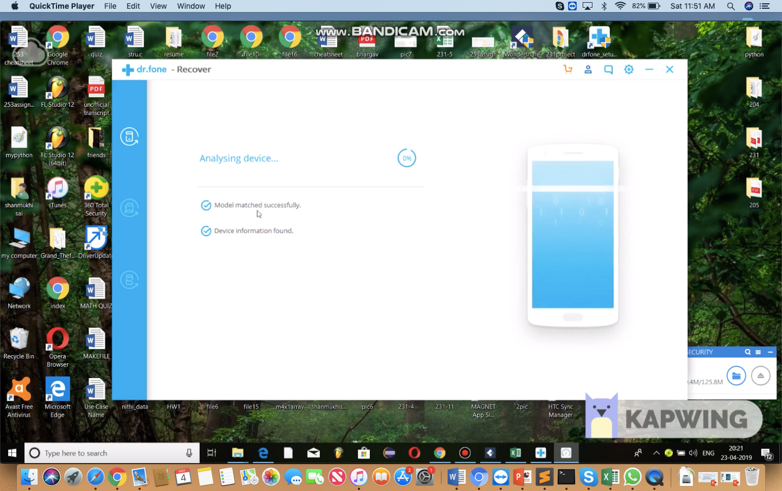

* Scanning is done and the phone keeps rebooting for about 30 to 40 minutes to recover the data, once the recovery is done data is saved into the selected disk folder. The recovered data is analyzed, and forensics investigation is performed on the retrieved data.

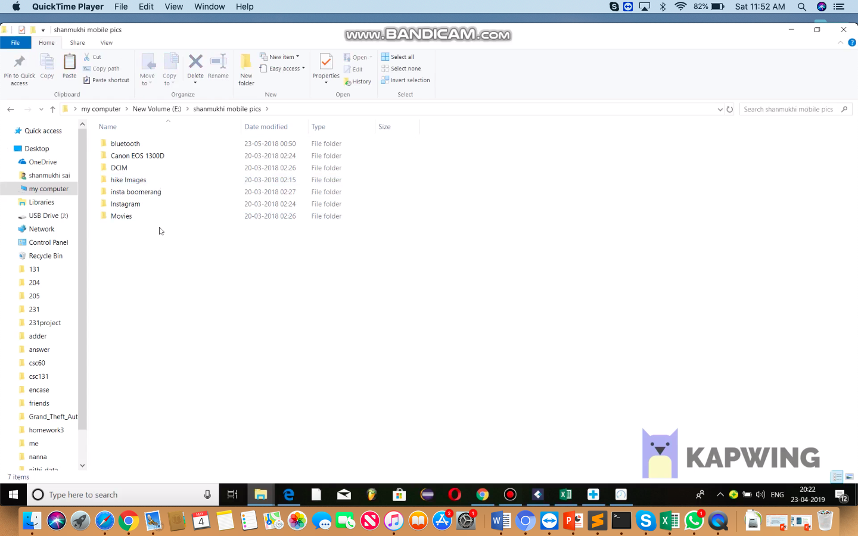

**OBSERVATIONS**

As we found three devices in suspects house the recovery of information is performed on all three of them and the recovered data is analyzed.

* Retrieved data from Windows system:

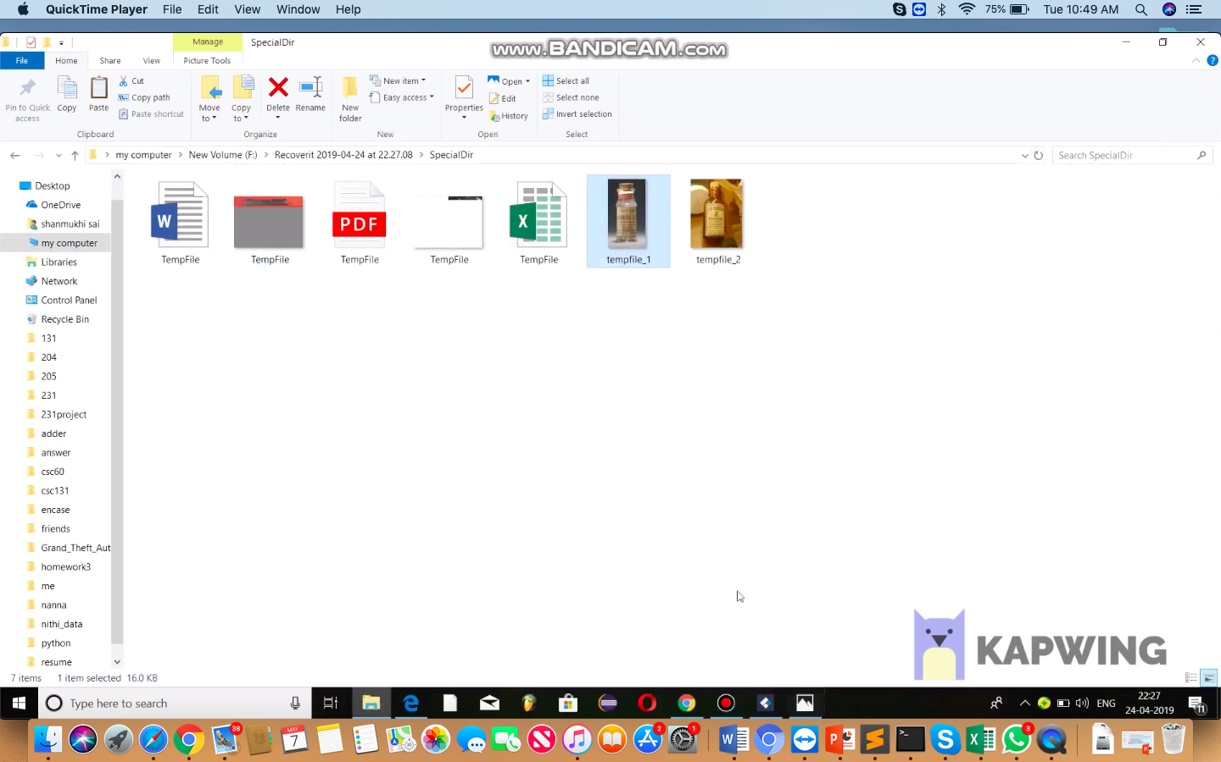

* Retrieved data from USB Drive:

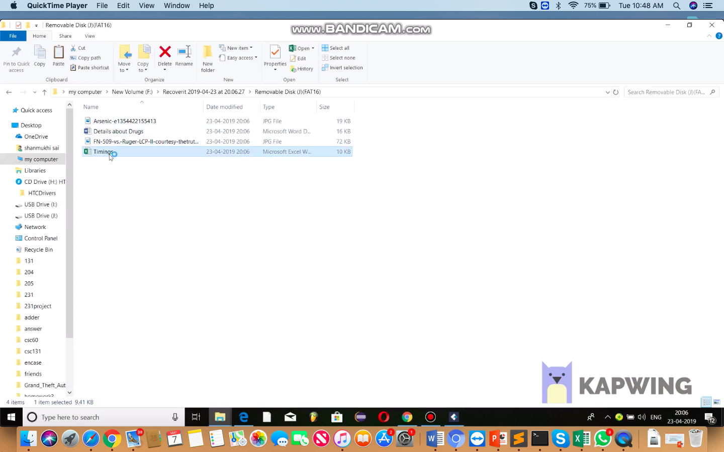

* Retrieved data from Mobile Phone:



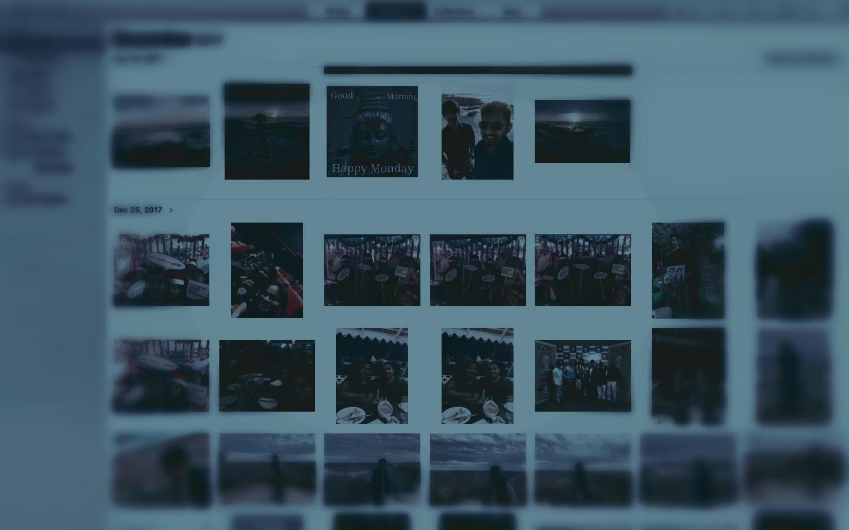

* In these recovered files we found out that the data which contains weekly and weekend schedule of the victim and the information present in the word document is about the different drugs not only that we found some of the victims’ pictures and drugs in suspects laptop. On investigating and making the forensics report we can tell who committed the crime.
* These tools Help us to retrieve the data which was ones present in the laptop, USB drive and Mobile phone and investigate on the retrieved data.

**CONCLUSION**

The goal of this project is to understand how to recover information from the electronic devices obtained from the crime scene and perform investigation on the data retrieved after the recovery. In this project, we performed File Forensics on a Windows Laptop, USB Drive and an Android mobile phone from the data retrieved once the recovery is done using Wondershare RecoverIt and Wondershare Dr. Fone.

We used Wondershare RecoverIt to capture all the information in the laptop by performing a scan on the system and following certain recovery steps and obtained the information needed. Also, we have understood how to retrieve information from an external device that is an USB drive and analyze the information.

We used Wondershare Dr. Fone by connecting the mobile device to the system and providing the access information needed to the application such as enabling the developer options in the phone and giving access to the USB debugging. Once the phone is connected it is scanned and we can retrieve any type of information related to the phone for instance Calls, messages, documents, application data etc.

From this project we were able to perform File Forensics on some devices and were able to understand many important forensic techniques and tools available as a part of investigation. These days, Computer Forensics plays a crucial role in Forensic investigation of most of crimes. It is important to know various techniques available before starting any investigation on the evidence.

**REFERENCES**

[1] Wondershare RecoverIt: <https://recoverit.wondershare.net/ad/data-recovery.html?gclid=CjwKCAjwza_mBRBTEiwASDWVviADipAi6RiJNia41MC7gZtn99LI6JDUfeWoqHrN5Gnz_oNLytU1HRoCTcIQAvD_BwE>

[2] Wondershare Dr. Fone: <https://drfone.wondershare.com/android-data-recovery.html>

[3] File Forensics: <https://resources.infosecinstitute.com/category/computerforensics/introduction/areas-of-study/digital-forensics/media-file-system-forensics/#gref>

[4] File Forensics: <http://www.campus64.com/digital_learning/data/cyber_forensics_essentials/info_file_system_forensic_analysis.pdf>